**WAD Project**

**By:** Daan Duijkers

Inhoud

Description 3

Pages 4

Home 4

Products 5

Shopping cart 6

Admin 7

Login 8

Register 9

GIT 10

# Description

What I will be making for this project is a shopping cart where people can order products and put them in a personal file and then order them to be delivered to their home. I personally wanted to make this for a while and this is a perfect opportunity!

# Pages

## Home

The page people first arrive at upon logging in. It has no functionality besides two links to the Products and Shoppingcart pages.

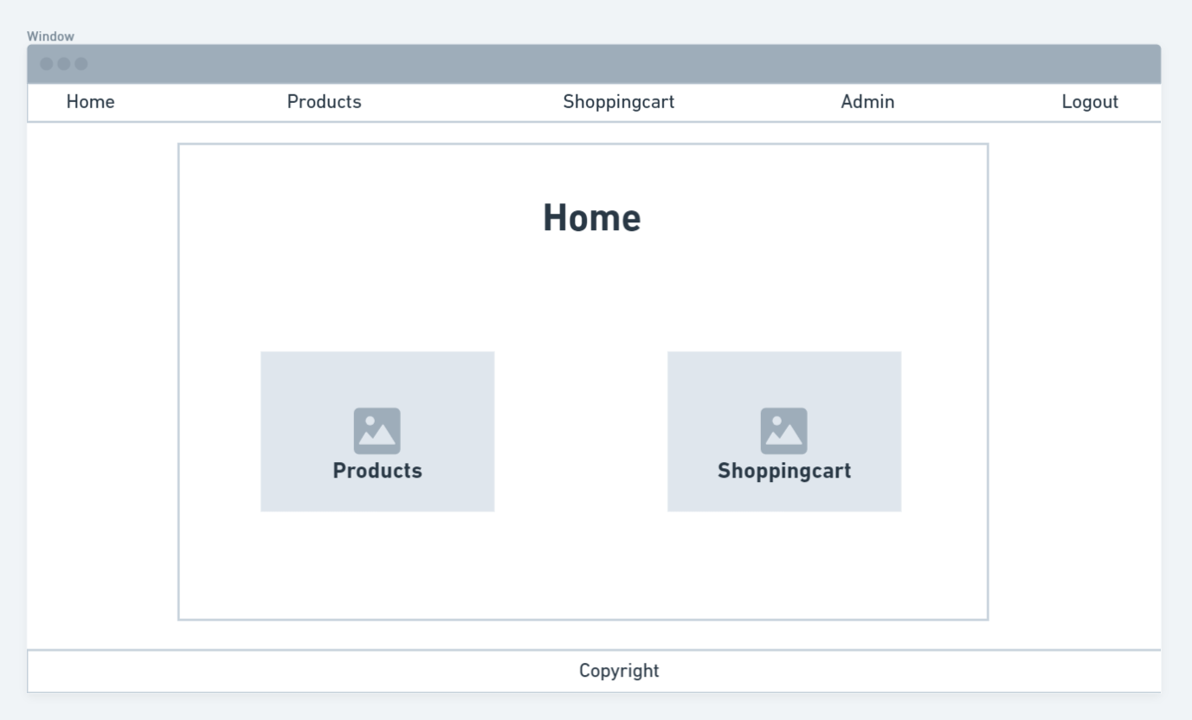

## Products

The products page is where the user can take a certain amount of a selected product and put it into their shopping cart. Those with admin right will also be able to refill the product quantity and whole new products.

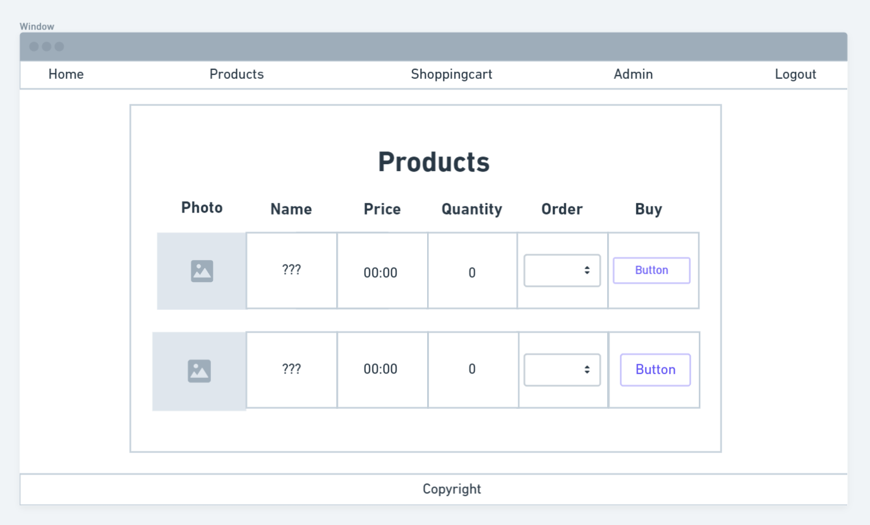

## Shopping cart

The shopping cart is where all the products go after the user selected them to be bought. Here they can select it buy it. Once this is done, the deal becomes unreversible!

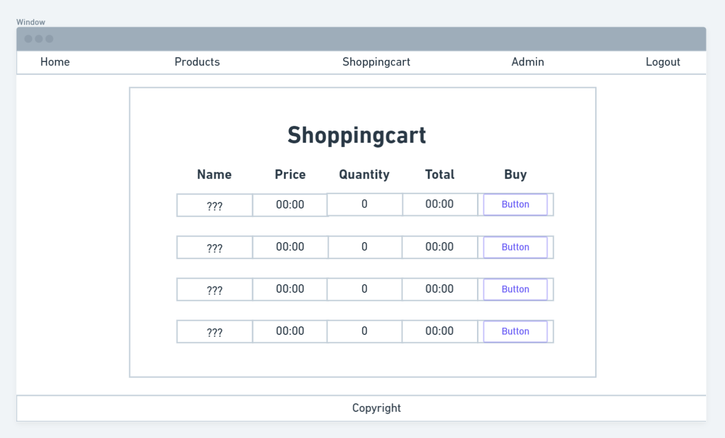

## Admin

A page exclusive to users with admin rights (normal users will not even be able to see the link). Here users with admin rights will be able to look up other users, promote them to admin status, and/or block them. They will also be able to make whole new accounts for users.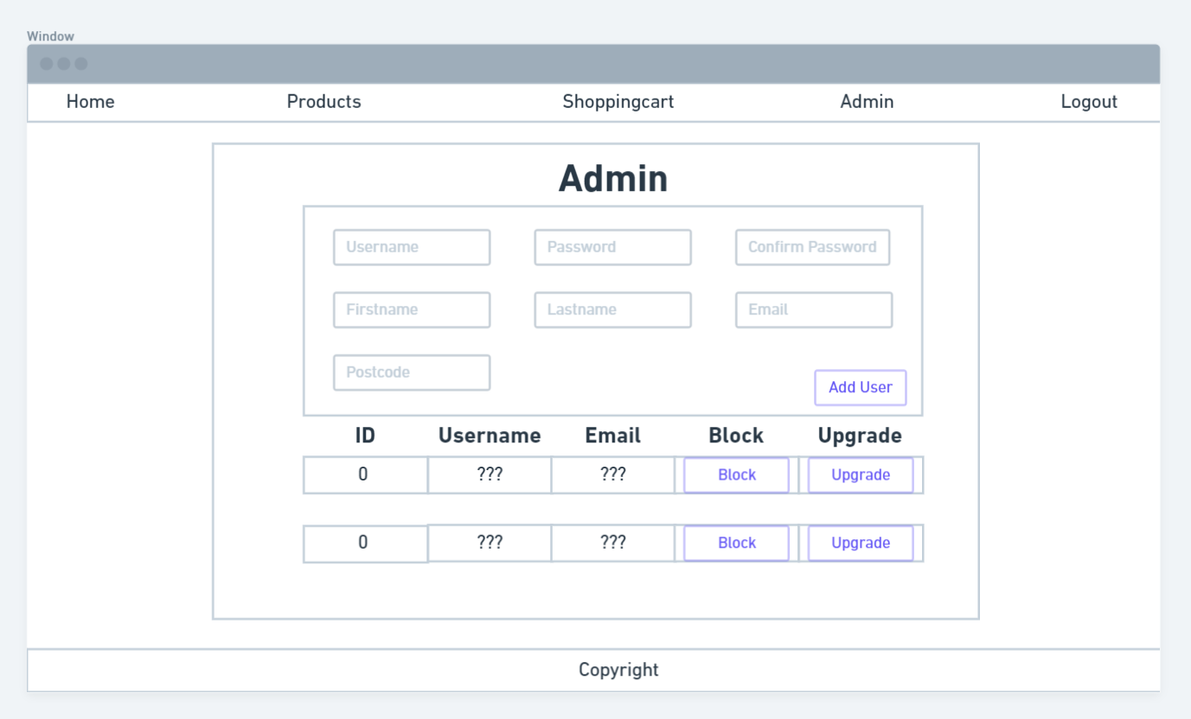

## Login

The first page the user enters upon entering the application. Here, they will have to fill in their username and password. If a false password is entered they will just be send right back to the page. If they do not have an account yet, they can otherwise also do to the register page to make one.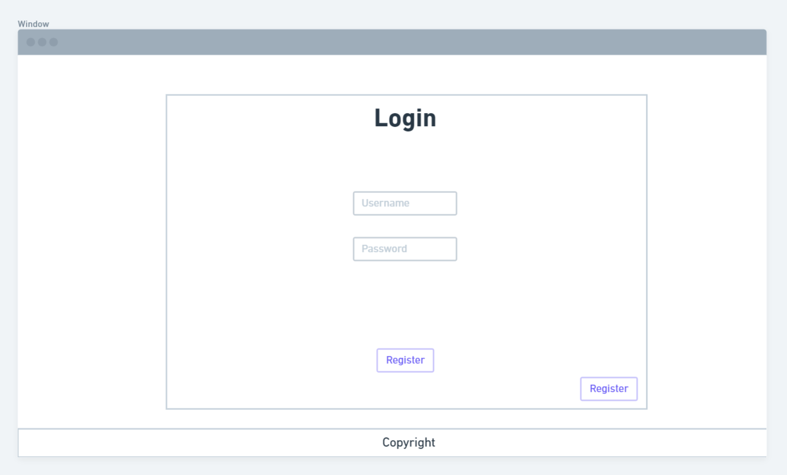

## Register

If a user does not have an account yet, they can go to this page to make one. The required data is: their username, their password (twice), their first name, their last name, their email, and their postcode. 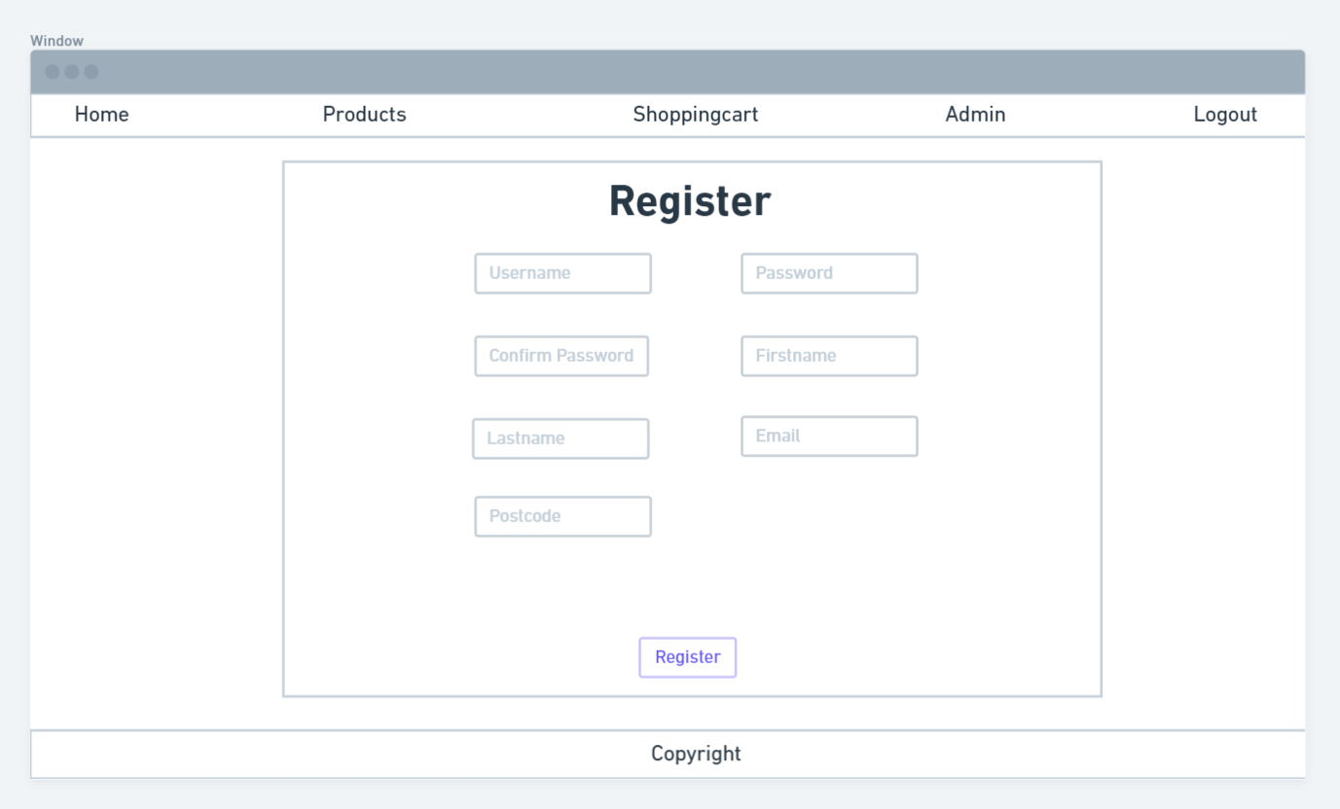

# GIT

[Duijkers,Daan D.P.T. / WAD Project · GitLab (fhict.nl)](https://git.fhict.nl/I435906/wad-project)